JENKINS INSTALLATION

* Install Docker locally (probably using Docker Desktop is the easiest approach
* Create docker file.

FROM jenkins/jenkins:lts-jdk17

USER root

RUN apt-get update && apt-get install -y lsb-release

RUN curl -fsSLo /usr/share/keyrings/docker-archive-keyring.asc \

https://download.docker.com/linux/debian/gpg

RUN echo "deb [arch=$(dpkg --print-architecture) \

signed-by=/usr/share/keyrings/docker-archive-keyring.asc] \

https://download.docker.com/linux/debian \

$(lsb_release -cs) stable" > /etc/apt/sources.list.d/docker.list

RUN apt-get update && apt-get install -y docker-ce-cli

USER jenkins

* Build the docker image from docker file.

docker build -t my-jenkins .

* Create docker compose file

version: '3.7'

services:

jenkins-docker:

image: docker:dind

container_name: jenkins-docker

privileged: true

environment:

- DOCKER_TLS_CERTDIR=/certs

volumes:

- jenkins-docker-certs:/certs/client

- jenkins-data:/var/jenkins_home

ports:

- "2376:2376"

networks:

jenkins:

aliases:

- docker

command: --storage-driver overlay2

my-jenkins:

image: my-jenkins

container_name: my-jenkins

restart: on-failure

environment:

- DOCKER_HOST=tcp://docker:2376

- DOCKER_CERT_PATH=/certs/client

- DOCKER_TLS_VERIFY=1

volumes:

- jenkins-data:/var/jenkins_home

- jenkins-docker-certs:/certs/client:ro

ports:

- "8080:8080"

- "50000:50000"

networks:

- jenkins

networks:

jenkins:

driver: bridge

volumes:

jenkins-docker-certs:

jenkins-data:

* Run the docker compose file

docker compose up -d

* Open Jenkins by going to: http://<server_ip>:8080/ and finish the installation process.
* After opening the above url, it will ask for password, We will get the password from the container where jenkins is installed.
* Login to the container where jenkins is installed(
* Go to the below path and open the file “initialAdminPassword”

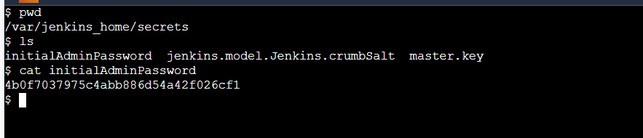

* Use this password to login to jenkins.